FCIS Deep Learning Competition

Computational Intelligence

**Team 19:**

* Ahmed Hassan Abdelsalam
* Arsany Maged Magdy
* Osama Fawzy Elsayed
* Ahmed Hassan Ali
* Ahmed Elmotaz Ahmed

Trials:

**Model = inception_resnet_v2**

epochs = 10

test size=0.3

IMG_SIZE = 100

accuracy = 40.76

**Model = xception**

epochs = 10

test size=0.3

IMG_SIZE = 100

accuracy = 50.11

**Model = inception_resnet_v2**

epochs = 10

test size=0.3

IMG_SIZE = 150

accuracy = 67.52

**Model = vgg19**

epochs = 10

test size=0.3

IMG_SIZE = 100

accuracy = 72.72

**Model = vgg16**

epochs = 10

test size=0.3

IMG_SIZE = 100

dropout=0.5

accuracy = 75.69

**Model = vgg19**

epochs = 10

test size=0.3

IMG_SIZE = 100

dropout=0.5

accuracy = 76.01

**Model = vgg19**

epochs = 10

test size=0.3

IMG_SIZE = 100

dropout=0.5

batch size = 64

accuracy = 75.16

**Model = vgg19**

epochs = 10

test size=0.3

IMG_SIZE = 150

dropout=0.5

batch size = 64

accuracy = 77.28

**Model = vgg19**

epochs = 10

test size=0.2

IMG_SIZE = 150

dropout=0.5

batch size = 64

accuracy = 78.66

**Model = vgg19**

epochs = 20

test size=0.2

IMG_SIZE = 150

dropout=0.2

batch size = 64

accuracy = 80.57

**Model = vgg19**

epochs = 10

test size=0.2

IMG_SIZE = 200

dropout=0.5

batch size = 64

accuracy = 82.32

**Model = vgg16**

epochs = 30

test size=0.2

IMG_SIZE = 200

dropout=0.5

batch size = 64

accuracy = 84.31

**Model = vgg16**

epochs = 30

test size=0.2

IMG_SIZE = 299

dropout=0.5

batch size = 64

accuracy = 86

**Model = inception_resnet_v2**

epochs = 30

test size=0.2

IMG_SIZE = 299

dropout=0.5

batch size = 64

accuracy = 91

**Model = inception_resnet_v2**

epochs = 10

test size=0.2

IMG_SIZE = 350

dropout=0.5

batch size = 64

accuracy = 91

**Model = mobilenet_v2**

epochs = 10

test size=0.2

IMG_SIZE = 224

dropout=0.5

batch size = 64

accuracy = 79.4

**Model = inception_resnet_v2**

epochs = 10

test size=0.2

IMG_SIZE = 299

dropout=0.5

batch size = 64

adding dense layer

accuracy = 89.4

**Model: vgg19**

Weights: ImageNet

Optimizer: Adam

Loss = Catergorical_crossentropy

accuracy = 74.6

**Model Vgg19**

Optimizer: adagrad

accuracy = 65.7

**Model: Resnet50**

Weights: ImageNet

Optimizer: Adam

Loss: categorical_crossentropy

Accuracy = 21.3

**Model Vgg19**

Weights = ImageNet

Optimizer = Adam

Loss = mean Squared Error

Accuracy = 74.8

**Model = Vgg19**

Weights = ImageNet

Optimizer = Adam

Loss = Categorical_Crossentropy

Epochs = 50

Batch size = 32

Accuracy = 73.7

**Model = Vgg16**

Weights = ImageNet

Optimizer = Adam

Loss = Categorical_crossentropy

Epoch = 10

Batch size = 100

Accuracy = 71.6

**Model = inception_resnet_v2**

epochs = 10

test size=0.2

IMG_SIZE = 299

dropout=0.5

batch size = 64  
Without normalization

accuracy = 15

**Model = inception_resnet_v2**

epochs = 26

test size=0

IMG_SIZE = 299

dropout=0.2

batch size = 64

Taring accuracy = 98

**Inception Resnet V2 Architecture**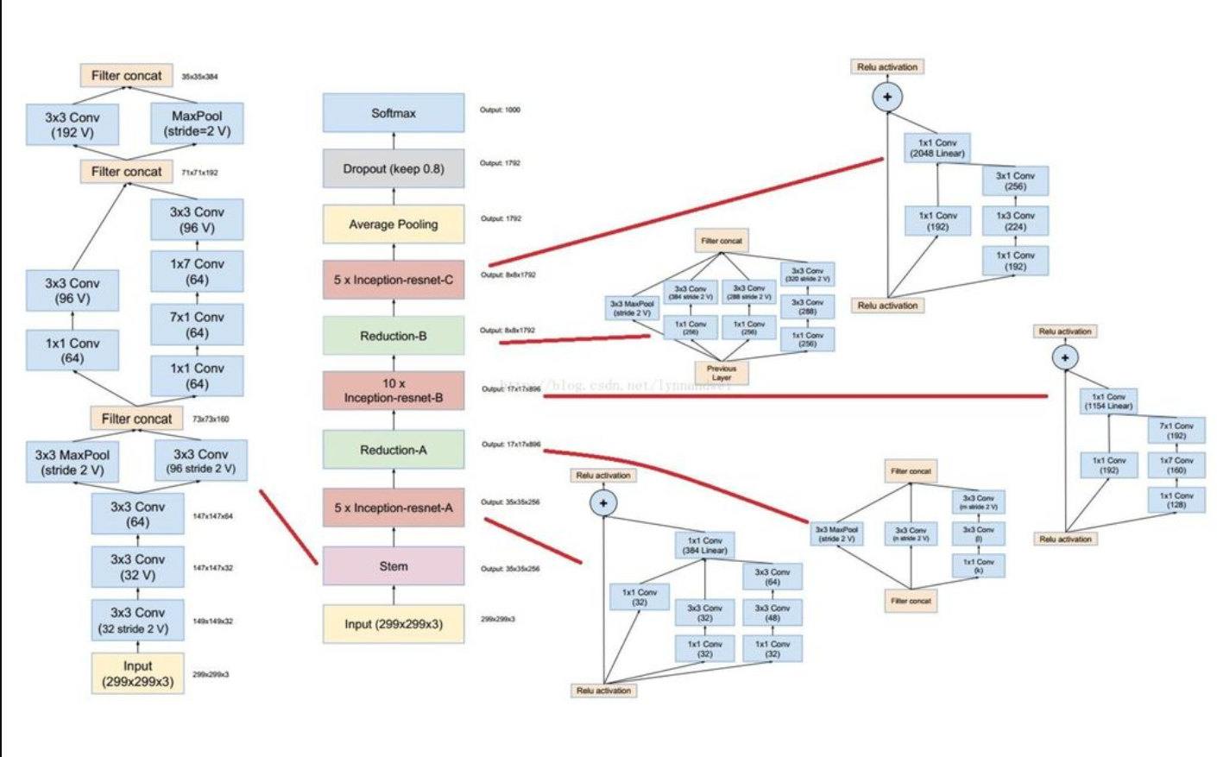

**Conclusion:**

We achieved the best accuracy by using Model : inception Resnet v2, Image size:299, Batch size 64, Dropout 0.2